In this video we will discuss about **installing asp.net mvc**. Before installing asp.net mvc, first let's determine what version is already installed. Go to **"Control Panel"** and click on **"Programs and Features"**. On my computer at the moment I only have asp.net mvc 2 as shown below.  
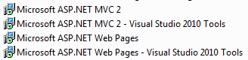

Since I just have **mvc 2**. I only can create asp.net mvc 2 web applications using visual studio. If you want to create asp.net mvc 3 or 4 applications, then please download and install asp.net mvc 3 and 4 from the following locations.   
  
**ASP.NET MVC 3**  
<http://www.asp.net/mvc/mvc3>  
  
**ASP.NET MVC 4**  
<http://www.asp.net/mvc/mvc4>  
  
After successful installation of mvc 3 and 4, Programs and Features window on my computer is as shown below.  
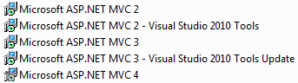   
  
When you create a new project, make sure you have .NET Framework 4 selected in the drop down list. If you have any other earlier .net framework versions selected, then ASP.NET MVC 3 Web Application and ASP.NET MVC 4 Web Application templates will not be available.